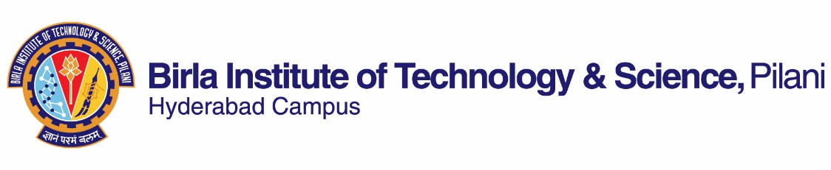

**SECOND SEMESTER 2021-22**

**Course Handout (Part II)**

# Date: 13.01.2022

In addition to Part-I (General Handout for all courses appended to the Timetable) this portion gives further specific details regarding the course.

***Course No.* : CHEM G552**

***Course Title* : Advanced Inorganic Chemistry**

***Instructor-in-charge* : Himanshu Aggarwal**

***Instructors* : Himanshu Aggarwal and Sounak Roy**

**Course Description :** Advanced coordination chemistry, reactions, kinetics and mechanism; advanced organometallic chemistry, bonding models in inorganic chemistry, inorganic chains, rings, cages and clusters; group theory and its applications to crystal field theory, molecular orbital theory and spectroscopy (electronic and vibrational); inorganic chemistry in biological systems

1. **Scope and Objective of the Course:** Theories of coordination chemistry, electronic spectroscopy and magnetism of complexes, organometallic chemistry and chemistry of lanthanides and actinides.
2. **Text Book:** T1. “ Inorganic Chemistry” Huheey J. E., Keiter, Ellen A., Keiter, Richard L., Medhi, O.K.; 4th ed., Pearson.

**Reference Books:** R1. "Concise Inorganic Chemistry", Lee, J.D. 5th Edition, Wiley, India Edition.  
R2 "Inorganic Chemistry", Shriver, D.F.; Atkins, P.W.; Overton T. L., Rourke, J. P., Weller, M. T., Armstrong, F. A.  4th edition, Oxford.  
R3 "Concepts & Models of Inorganic Chemistry" B. Douglas, D. McDaniel and J. Alexander 3rd Edn, wiley India.

1. **Course Plan:**

|  |  |  |  |
| --- | --- | --- | --- |
| **Lecture No.** | **Learning Objectives** | **Topics to be covered** | **Chapter in the Text Book** |
| 1-2 | Coordination chemistry | Coordination chemistry: Bonding  VB theory applied to coordination compounds | T1:Chapter14: 424-428 |
| 3-5 | Crystal Field Theory (CFT) | Crystal Field Theory (CFT): Crystal field splitting; d orbitals in different crystal fields; applications of CFT | T1:Chapter 14: 428-444 |
| 6-8 | Molecular orbital theory | Molecular orbital theory | T1:Chapter 14: 444-459 |
| 9-12 | Electronic spectra of complexes, Magnetic properties of complexes | Electronic spectra of complexes, Magnetic properties of complexes | T1:Chapter 15: 461-492 |
| 13-15 | Structure Nomenclature | Structure – Nomenclature, Coordination numbers 1, 2, 3, 4, 5, 6, 7  Generalization about coordination numbers  Isomerism: Linkage and other types of isomerism  Chelate effect | T1:Chapter 16: 495-539  Lecture notes |
| 16-20 | Reactions of coordinated complexes | Reactions – Nucleophilic substitution reactions, Kinetics, Mechanisms | T1:Chapter 17 (542-569) and Lecture notes |
| 21-30 | Organometallic chemistry | The 18-electron rule  Metal-carbonyl complexes  Nitrosyl complexes  Dinitrogens  Alkyls  Carbenes, Carbynes, Carbides  Alkenes  Alkynes  Metallocenes | T1:Chapter 18 and Lecture notes |
| 31-38 | Catalysis and reaction mechanisms. | Catalysis by organometallic compounds  Stereo chemically non-rigid molecules | T1:Chapter 19 (634-661)  T1:Chapter 6 (196-202) |
| 39-40 | Lanthanide and actinide chemistry | Descriptive chemistry of metals - The Lanthanides and Actinides | T1:Chapter 13 (407- 419)  Lecture notes |

1. **Evaluation Schedule:**

|  |  |  |  |  |
| --- | --- | --- | --- | --- |
| Component | Duration | Weighting (%) | Date and Time | Nature of Component |
| Class tests, Assignments and presentations | - | 40 | Continuous | Open Book |
| Mid Semester Test | 90 min | 25 | As announced by Time Table | Closed Book |
| Comprehensive  Examination | 120 min | 35 | As announced by Time Table | Closed Book |

1. **Chamber consultation hour:** To be announced in the class.
2. **Make-up for tests:** May be granted only for genuine cases.
3. **Notices:** All notices for this course will be displayed in the Chemistry Notice Board.
4. **Academic Honesty and Integrity Policy**: Academic honesty and integrity are to be maintained by all the students throughout the semester and no type of academic dishonesty is acceptable

Instructor-in-charge

**CHEM G552**

